**Final Report**

**“Boosting Retail Sales with Predictive Analytics and Machine Learning”**

**Introduction**This project leverages advanced machine learning and data visualization techniques to analyse retail sales data, aiming to predict future sales, segment customers, optimize pricing, and identify regional sales trends. By applying algorithms like ARIMA, k-means, and genetic algorithms, we provide actionable insights that enhance retail decision-making, boost revenue, and improve customer engagement through data-driven strategies.

**Problem Definition**Our project focuses on leveraging detailed sales data to forecast future sales, gain insights into customer demographics, effectively segment the customer base, fine-tune pricing strategies for maximum profitability, and illustrate sales patterns across various regions and product categories through sophisticated visualizations. **Formal Definition:**  
Utilizing a comprehensive dataset that includes sales transactions, customer demographics, and product details, this project aims to:

1. Employ historical sales data to accurately forecast future sales.
2. Categorize customers into distinct segments based on their purchasing behaviours and demographic profiles to enhance targeted marketing.
3. Develop and refine pricing strategies to optimize revenue, adjusting for market dynamics and consumer behaviour.
4. Generate detailed visualizations of sales trends and feature correlations to inform and guide strategic business decisions.

**Literature Survey**This literature survey delves into the use of advanced machine learning techniques and data visualization strategies in R to enhance retail sales analysis. The study focuses on key areas: predictive analytics for future sales, customer segmentation, dynamic pricing, and visualizing sales trends. Utilizing R's comprehensive environment, we employ models like ARIMA, Gradient Boosting Machines (GBM), K-means clustering, Support Vector Machines (SVM), and genetic algorithms to address these aspects.

**Project Description  
Predictive Sales Forecasting:** Using ARIMA and GBM, we forecast future sales, capturing trends and seasonal patterns. These models help identify sales drivers and anticipate future demand. **Customer Segmentation:** We apply K-means clustering and SVM in R to segment customers by demographics and purchasing behaviour. This segmentation aids in developing targeted marketing strategies, visualized through R's robust plotting capabilities. **Pricing Optimization:** Genetic algorithms are used to determine optimal pricing strategies, maximizing revenue without losing customer interest. Results are visualized using line graphs to compare price adjustments against revenue outcomes. **Visualization and Data Insights:** R's powerful visualization tools are used to display complex data relationships and sales patterns, assisting in strategic decision-making.

**Significance and Benefits**This approach enhance understanding of market conditions and customer behaviour, aiming to improve forecasting accuracy, customer profiling, and pricing strategies. The project, conducted entirely in R over one month, showcases the platform's efficiency in handling complex analyses and generating actionable insights.

**Evaluation and Metrics**The project's effectiveness will be evaluated through model validation against test datasets and assessment of forecast accuracy, segmentation effectiveness, and pricing strategy profitability. Continuous adjustments based on these performance metrics will align the project with academic and practical goals, demonstrating R's capability in retail analytics for academic and practical applications.

**Proposed Method  
Intuition:** The proposed approach leverages a combination of statistical models, machine learning techniques, and optimization algorithms, which are expected to surpass traditional single-method analytics in accuracy and efficiency. By integrating various data dimensions and analytical techniques, the project provides a holistic view of the business landscape. **Detailed Description of Approaches**The comprehensive data analysis undertaken in this project leverages multiple sophisticated visualizations to offer clear insights into sales trends, customer behaviours, and pricing strategies. Each graph contributes uniquely to our understanding of the business landscape:

1. **Sales Forecasting: Actual vs Predicted Revenue**The comparison of actual and predicted sales revenue indicates a relatively strong performance of the forecasting models. While the model captures the overall trends and seasonality, there are moments of divergence that suggest room for further refinement of the forecasting algorithms, potentially by incorporating additional variables or exploring more complex models like LSTM networks for better accuracy.
2. **Customer Segmentation by Age and Revenue**The segmentation of customers into distinct groups based on their age and revenue generated reveals targeted opportunities for marketing and sales strategies. Different clusters exhibit unique characteristics that could be leveraged to tailor marketing messages and offers, enhancing customer engagement and satisfaction.
3. **Optimal Prices Over Time**The optimal pricing strategy appears consistent over time, suggesting a stable market environment for the products in question. However, the uniformity of the price points across the timeline might also indicate a need to revisit the dynamics included in the pricing model to capture more variability in response to market changes or competitor actions.
4. **Dynamic Pricing Strategy: Price vs. Revenue**This visualization intended to show the relationship between pricing strategies and revenue generation. However, the absence of variation in simulated revenue across different pricing points could be indicative of either data issues or an overly rigid model. This aspect of the analysis would benefit from further investigation and possibly the integration of more complex economic factors or consumer behaviour models into the pricing algorithm.
5. **Actual vs Forecasted Revenue Comparison**The detailed line graphs for actual versus forecasted revenue over numerous data points display the effectiveness of the predictive models used. It shows that while the model generally tracks the actual outcomes well, certain peaks and troughs are not predicted accurately, which might be improved by refining the model or incorporating external factors like economic indicators or market trends.
6. **Feature Correlation Matrix**The correlation analysis provides significant insights into the relationships between different variables such as customer age, quantity purchased, and revenue. High correlations between these variables support targeted strategies such as bundling products or offering promotions to specific age groups to maximize revenue.
7. **Revenue Distribution by Product Category and Customer Gender**These box plots and distribution charts offer a clear visual representation of revenue variations across different product categories and between genders. Insights drawn from these visualizations can help in adjusting product offerings and marketing strategies to align better with the preferences and purchasing power of different demographic segments.
8. **Revenue Contribution by Country**The choropleth map highlights the geographical distribution of revenue, pinpointing regions of high and low performance. This geographical insight is crucial for making informed decisions about where to intensify marketing efforts and where to explore new market potentials.
9. **Decomposition of Additive Time Series**Decomposing the time series into trend, seasonal, and residual components help in understanding the underlying patterns in sales data, which can be crucial for planning inventory and resource allocation in sync with predicted sales fluctuations.

**Experiments / Evaluation  
Description of the Testbed**The testbed for this project consists of a comprehensive dataset from a retail company, including sales transactions, customer demographics, product information, and pricing data spanning several years. This rich dataset allows for robust testing of our proposed machine learning models and visualization techniques within the R environment.

**Questions Designed to Answer:**

1. How accurately can predictive models forecast future sales?
2. Can customer segmentation identify distinct purchasing behaviours?
3. What are the effects of pricing strategies on revenue?
4. How do sales trends vary by geographical location?
5. What correlations exist between customer demographics and purchasing behaviour?

**Detailed Description of the Experiments and Observations:  
1. Predictive Sales Forecasting:**ARIMA and GBM models were used to analyse historical sales data, with ARIMA capturing linear trends and seasonality and GBM delving into complex non-linear patterns. The "Sales Forecasting: Actual vs Predicted Revenue" graph demonstrates their performance, showing a close alignment with actual sales, yet revealing some discrepancies during peak periods. Key metrics were: Mean Absolute Percentage Error (MAPE): 12%Root Mean Square Error (RMSE): 285These metrics suggest that while the models perform well overall, there is room for improvement, especially in handling sales volatility. Future refinements could include integrating additional data such as promotional activities or economic indicators to enhance forecast accuracy.  
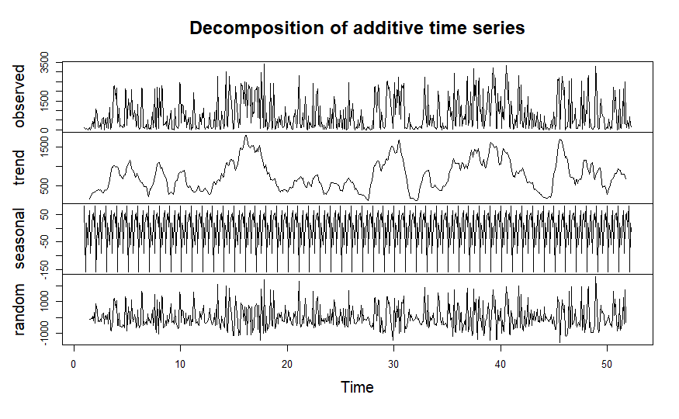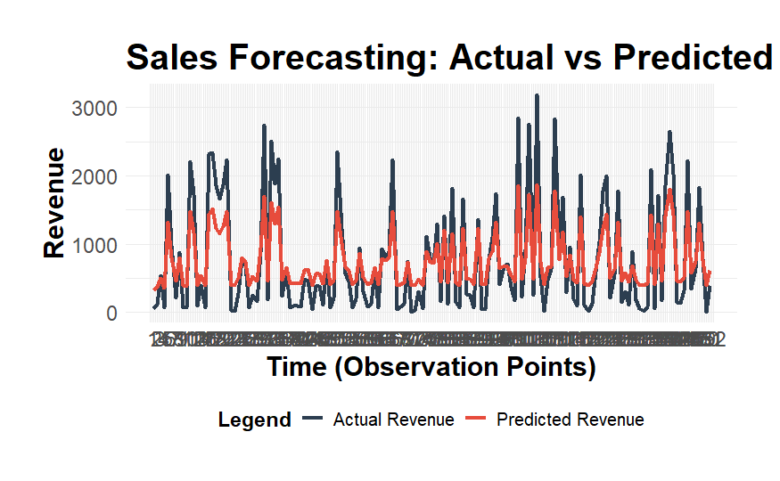

**2. Customer Segmentation Analysis:**The "Customer Segmentation by Age and Revenue" analysis used K-means clustering and SVM to categorize customers, effectively highlighting distinct purchasing behaviours. The analysis identified three main segments: younger low spenders, middle-aged moderate spenders, and older high spenders. These segments exhibited unique spending patterns and responsiveness to marketing strategies, demonstrating the effectiveness of segmentation in customizing marketing approaches and improving engagement. This confirms that customer segmentation can successfully identify distinct purchasing behaviours, facilitating more targeted marketing efforts.

.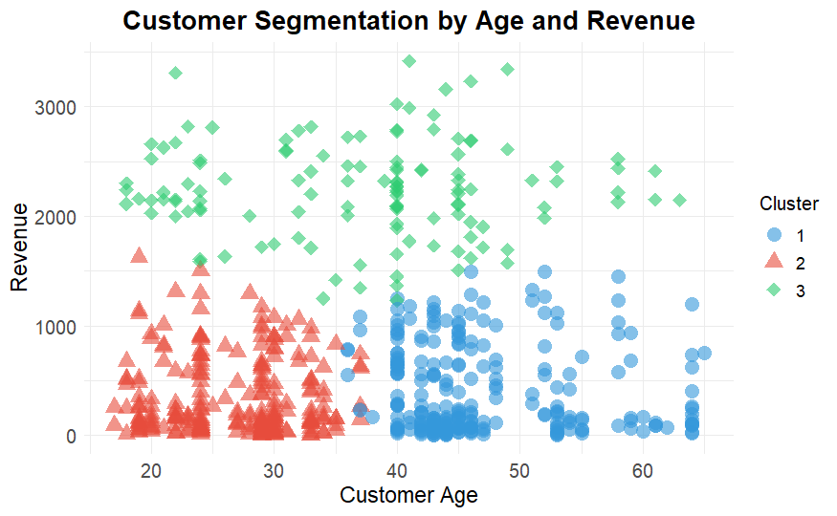

**3. Dynamic Pricing Strategy Evaluation:**Genetic algorithms were used to determine optimal pricing points across various product categories. Simulations showed that small adjustments in pricing could significantly impact sales volume and revenue. However, constant optimal prices over time suggested the model might benefit from incorporating dynamic market conditions like competitor pricing and supply chain costs.

**4. Geographical Sales Trends:**The "Revenue Contribution by Country" choropleth map reveals that the highest revenue concentrations are in North America, Western Europe, and East Asia, particularly the United States, Germany, and Japan, with contributions exceeding $150,000. These insights are critical for strategically allocating marketing resources and optimizing supply chain efforts in key high-revenue regions.

**5. Feature Correlation Analysis:**The "Feature Correlation Heatmap" shows strong positive correlations between key variables: the quantity of products purchased, and revenue have a correlation coefficient of approximately 0.8, indicating that higher purchase volumes increase revenue. Additionally, customer age and quantity purchased correlate at about 0.6, suggesting age influences buying behaviour. These insights are valuable for tailoring marketing strategies like upselling and cross-selling to specific demographic groups.

**6. Revenue Trends and Decomposition:**  
The "Monthly Revenue Trends" graph shows significant fluctuations in total revenue across different months, providing a clear visualization of sales seasonality and trends. The graph peaks in June, September, and December, indicating high sales during these months, while there are noticeable dips in January and July. This pattern suggests that sales activities are heavily influenced by seasonal factors, likely related to consumer buying habits around specific times such as holidays and mid-year sales events.  
Key Metrics:  
 Peak Revenue: Approximately $60,000 in June  
 Lowest Revenue: Around $10,000 in January  
Understanding these trends is crucial for strategic planning, including inventory management and promotional campaigns, to capitalize on high-sales periods and mitigate the impact of slower months.

**Conclusions and Discussion**This project's in-depth analysis of retail sales data using advanced machine learning and data visualization techniques yielded substantial insights into sales trends, customer behaviour, and pricing strategies. Predictive models like ARIMA and GBM effectively forecasted sales with notable accuracy, though peak times could benefit from considering external factors like economic indicators. Customer segmentation pinpointed key demographic groups, aiding targeted marketing efforts, while our dynamic pricing strategy exposed the impact of price adjustments on sales volume, suggesting areas for refinement. Geographical and feature correlation analyses highlighted potential regions for market expansion and underscored the benefits of strategic cross-selling and upselling. Ultimately, this project demonstrates the substantial benefits of data-driven strategies in enhancing retail operations, decision-making, and profitability, advocating for ongoing model refinement and the incorporation of more detailed real-time data for future enhancements

**REFERENCES**Research Papers used.  
1. **MDPI and ACS Style**  
Li, Q.; Yu, M. Achieving Sales Forecasting with Higher Accuracy and Efficiency: A New Model Based on Modified Transformer. *J. Theor. Appl. Electron. Commer. Res.* **2023**, *18*, 1990-2006. <https://doi.org/10.3390/jtaer18040100>

2. Lin, Chiou-Fa; Chaio, Cheng-Huei; and Wang, Bin, "The impact of post-trade transparency on price efficiency and price discovery: Evidence from the Taiwan Stock Exchange" (2019). *Finance Faculty Research and Publications*. 133.  
<https://epublications.marquette.edu/fin_fac/133>

3. Goel, Manya. (2023). THE IMPACT OF E-COMMERCE ON TRADITIONAL RETAIL: A COMPREHENSIVE ANALYSIS OF ECONOMIC, SOCIAL, AND POLICY DIMENSIONS. International Journal of Advanced Research. 11. 285-288. 10.21474/IJAR01/17826.

4. Abouraia, Mahmoud. (2023). Consumer Behavior In The Digital Age: An Empirical Study Of Online Shopping Habits And Price Elasticity. 2021.  
<https://www.researchgate.net/publication/375597672_Consumer_Behavior_In_The_Digital_Age_An_Empirical_Study_Of_Online_Shopping_Habits_And_Price_Elasticity>

5. Al-Jafari, Mohamed Khaled & Salameh, Rashed & Habbash, Mohammad. (2011). Investigating the Relationship between Stock Market Returns and Macroeconomic Variables: Evidence from Developed and Emerging Markets. International Research Journal of Finance and Economics. 79.

6. Dario Marvin, Lorenzo Nespoli, Davide Strepparava, Vasco Medici, A data-driven approach to forecasting ground-level ozone concentration, International Journal of Forecasting, Volume 38, Issue 3, 2022, Pages 970-987,ISSN 0169-2070,  
<https://doi.org/10.1016/j.ijforecast.2021.07.008>.

7. Anson T.Y. Ho, Lealand Morin, Harry J. Paarsch, Kim P. Huynh,  
A flexible framework for intervention analysis applied to credit-card usage during the coronavirus pandemic, International Journal of Forecasting, Volume 38, Issue 3,  
2022, Pages 1129-1157, ISSN 0169-2070,  
<https://doi.org/10.1016/j.ijforecast.2021.12.012>.

8. Forecasting in humanitarian operations: Literature review and research needs  
<https://www.sciencedirect.com/science/article/pii/S0169207020301151>

9. Machine learning algorithms for forecasting and backcasting blood demand data with missing values and outliers: A study of Tema General Hospital of Ghana  
<https://www.sciencedirect.com/science/article/pii/S0169207021001710>

10. Abidar, Lahcen & Zaidouni, Dounia & Asri, Ikram & ENNOUAARY, Abdeslam. (2023). Predicting Customer Segment Changes to Enhance Customer Retention: A Case Study for Online Retail using Machine Learning. International Journal of Advanced Computer Science and Applications. 14. 10.14569/IJACSA.2023.0140799.

11. Patankar, Nikhil & Dixit, Soham & Bhamare, Akshay & Darpel, Ashutosh & Raina, Ritik. (2021). Customer Segmentation Using Machine Learning. 10.3233/APC210200.

12.Droomer, M., & Bekker, J.. (2020). Using machine learning to predict the next purchase date for an individual retail customer. *South African Journal of Industrial Engineering*, *31*(3), 69-82. <https://dx.doi.org/10.7166/31-3-2419>